Stirring Subsystem
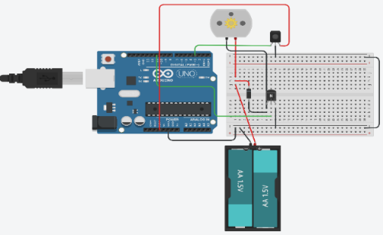
Vaccines are required to be regulated and maintained at certain temperature and pH ranges as already mentioned, for them to be effective for the patient. The pH subsystem and the heating subsystem are able to change the pH and the temperature of the solution near the actuators of both subsystems. However, in order to keep the pH and the temperature of the entire solution at a constant desired range a stirring subsystem is required. It allows the molecules of the entire solution to be in contact with the acid, base, or the heating element, thus causes the entire solution to change pH or temperature, and not only one section of the solution.
Figure _: Circuit View of the Stirring subsystem
Equipment used:
3V DC motor (maximum current 1A), CP2S700HCP photo-interrupter, NPN BJT Transistor (ZTX450), wires, Arduino UNO, 1N4001 diode, 3V lead acid battery.
For the DC motor to function optimally without harming the Arduino, a NPN BJT transistor was used. This is because the maximum current per pin in the Arduino is 40 mA. A NPN transistor was used instead of a PNP because its’ majority carriers is the electron, suggesting that the electrons will have faster transitions. If any component connected to the Arduino utilises higher current than the pin may become damaged and unusable. The transistor used has a collector rating of 1 A, making it suitable for the subsystem. The base of the transistor is connected to pin 11 (PWM). This is because this pin provides a variation of pulse widths which can be chosen by the user. Therefore, different DC voltages are provided to the motor, thus changing the duty cycle of the motor. The duty cycle is the average time the signal from the Arduino is ON in a whole period. Being able to control the duty cycle allows the user to vary the RPM of the motor. The emitter of the transistor is connected to ground to avoid any electric shocks from occurring when in contact with the wires of the circuit and the collector is connected to the power supply. The diode is connected parallel to the DC motor to stop the induced emf produced in the conducting loop which is located in the motor to travel through the circuit. This emf opposes the supply voltage from the power supply. Therefore, when the circuit is disconnected from the power supply the voltage from the conducting loop increases a lot, which may damage the transistor and the Arduino. Thus, when the power supply is disconnected, the induced voltage is fed to the loop created by the diode.
To control the speed of the motor a PID control was used. The acronym stands for Proportional, Integral and Derivative controls. The purpose of the PID is to actively maintain the system at a set value; in this subsystem the set value is the speed of the motor. The proportional control is proportional to the error between the current and set speed of the motor. A large proportional control results to a fast change in the speed of the motor, thus possibly causing oscillations. The integral control affects the time of response of the PID control. It sums up previous errors and from there deduces whether the response to the current error should be quicker. The derivative control calculates the rate of change of the speed of the motor. The stirring system contains some specifications because having the motor spin very slowly may not provide the entire solution with the same temperature and pH, but a very large RPM may overheat the motor and damage the gearbox. The preferable range for the RPM should be between 500 – 1500 RPM within ±20 RPM of the set range. The optimal speed of a 3V DC miniature motor is 12,00 RPM. However, to maintain a lower speed for the motor the gearbox built in the motor is used.
When the code from the Arduino IDE begins, the motor rotates at about 300 RPM for 5 seconds. When the loop function begins the PID control changes the speed of the motor to maintain a constant RPM, with a bit of oscillation, at 550 RPM. The photo-interrupter sensor functions as a digital input. It signals ones when the propeller of the motor is not covering it and zeros when it is. The attachInterrupt function is set to RISING. This means the time between a zero and a one is recorded for a whole rotation. The motor contains two propellers, therefore, the time intervals recorded is the period of the motor’s rotation. RPM has a unit of s⁻¹. It is the frequency of the rotation multiplied by 60 since it records the rotations per minute and not per second. Therefore, the equation used must be:
$$RPM=\frac{1}{2*t_{interval}}*60$$
In the code, the $\frac{1}{t_{interval}}$ is the Counter variable, this suggests why the following multiplication is used
$$RPM=Counter*30$$
Analysis and Testing
Calibration had to follow to guarantee the readings shown on the Serial monitor of the Arduino IDE is correct. This is because the RPM recorded by the photo-interrupter, which is displayed on the serial monitor should be approximately equal to the instrument normally used for measuring the rotation speed, the tachometer. If the tachometer displays similar values with our Arduino IDE, then the photo-interrupter and the motor are working accurately, and that the equation is correct. To prove the RPM of the motor is correctly described on the Serial Monitor the relationship between the RPM depicted on the Serial Monitor should be linearly proportional to the duty cycle of the motor. A graph was produced on MATLAB by testing the RPM of the motor for various duty cycles. The Graph is moderately accurate, suggesting that our subsystem is recording the RPM correctly.
Graph_: Graphical representation of relationship between the RPM of the motor with its duty cycle
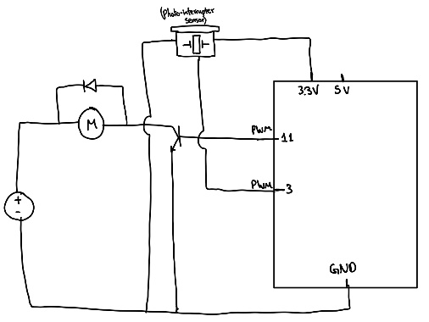
Figure _: Schematic View of the Stirring subsystem

Conclusion
The motor was able to rotate between the specified range. However, for a short period of time the RPM of the motor would fluctuate, making it harder for the user to observe the current RPM of the motor. This happened because the constants used for the PID control were not tuned well enough to fit the needs of the dc motor. The RPM was overshooting and ringing, meaning the PID control would go higher than the set value and would also oscillate around 700 RPM. To fix this problem, we had to tune the PID constants to make the response of the current RPM to the set value RPM efficiently quick and accurate. Due to this error, a ‘back-up’ code was created without a PID control but controlled through the user by using the Serial Monitor. This was created to achieve redundancy to improve our chances of a reliable and successful control system.

https://www.news-medical.net/health/Why-do-Vaccines-need-to-be-Refrigerated.aspx
https://forum.arduino.cc/t/arduino-uno-current-limits-and-vin/620789
http://www.datasheet.hk/view_download.php?id=1729203&file=0366%5Cztx450_3245564.pdf
https://www.thorlabs.com/newgrouppage9.cfm?objectgroup_id=9013
https://manualzz.com/doc/14969661/datasheet-for-compact-8-000-rpm-hobby-motor-3v---6v-dc
https://www.zikodrive.com/support/zikouniversity-motor-control-theory-application/when-should-i-add-a-gearbox-to-a-motor/#:~:text=Whilst%20there%20are%20occasionally%20gearboxes%20that%20will%20increase,torque.%20This%20can%20be%20done%20for%20several%20reasons.

